**Cash for Chores Project Proposal**

Fernando Davis Jean Rodríguez

Hector Jimenez Felix Dasta

Chaliana Rolon Angel Burgos

**Project Summary**

A design and development project for users wishing to provide household services online. Project will consist of a UI that will allow users to create their profiles, host household services, and request them, as well as a database to store this information. The team mentioned above will begin the design, implementation, and testing of this project which will take approximately one semester to complete.

**Project Background**

Currently, household service providers do not have an efficient and effective platform to both connect with potential customers as well as collect feedback on the services they provide. At the same time, customers do not have an adequate platform for browsing and finding the household services they wish to hire as well as viewing and providing feedback on said services. This creates a need for a system that allows the provider to create a professional profile which will allow them to promote their services and collect feedback on them, and also allows the service consumer to create a personal profile which will allow them to browse for their desired services.

**Project Objective**

The project’s objective is to develop a platform that provides a better mean of communication between household service providers and customers. Said platform will allow for providers to advertise the services they offer directly to consumers online, and for consumers to view and provide constructive criticism and feedback about the services. It is crucial to possess a safe way of storing users’ personal information since their safety and satisfaction is our top concern. The project should also be aesthetically pleasing, easy to pick up, and simple to use in order to achieve user satisfaction.

**Project Scope**

To implement a platform with a UI that begins by prompting the user for their login credentials and, after validating them with the database, takes them to the main page where they can choose to browse for services, host them, or request them. The system will also consist of other pages for the creation of user accounts, for browsing services by criteria, and for providing feedback for services. The project will be developed following an agile methodology; more specifically, a scrum implementation where 2-3 meetings will be held weekly to assure project development is being accomplished.

**Project Architecture**

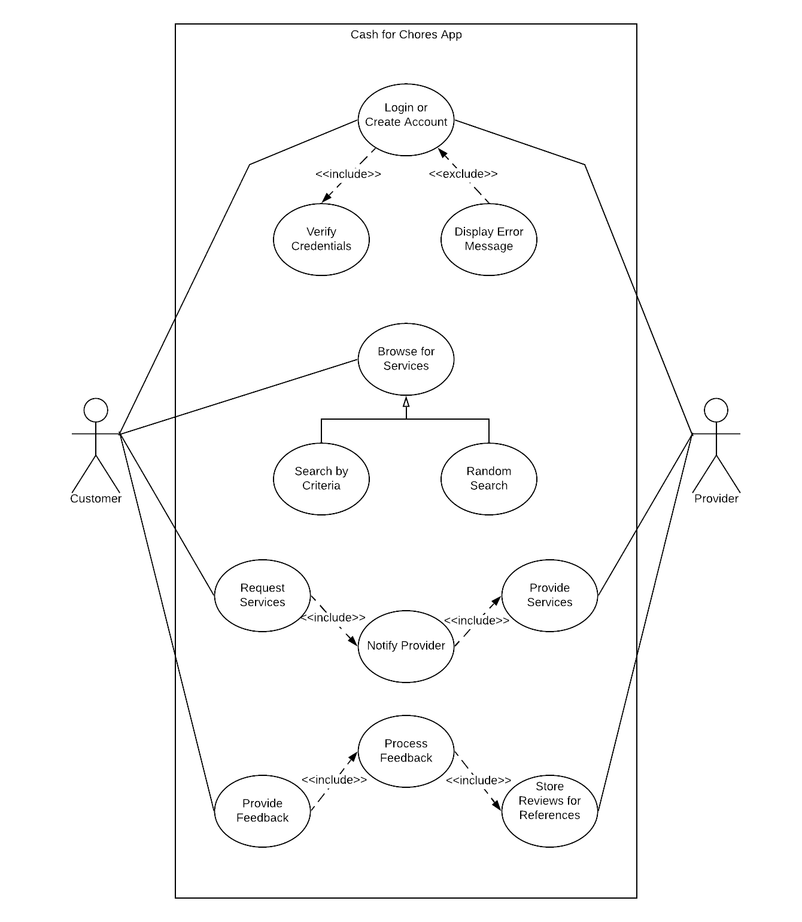

**Use Case Description:** There are various scenarios that will be played inside the app. The initial one will always be to either log in to your account or create a new one if necessary. When this happens, the system will always verify the credentials with the database to ensure they are correct, otherwise, it will display an error message. Customers can browse for services in an arbitrary way or by any search criteria of choosing. When ready, the customer will request a service through the app and the system will always follow by notifying the provider so that they can proceed to administer the service. Upon the completion of a service, the user can provide feedback which will then be processed by the system and publicly displayed in the feedback area of that specific service for other users to see.

**Project Model**

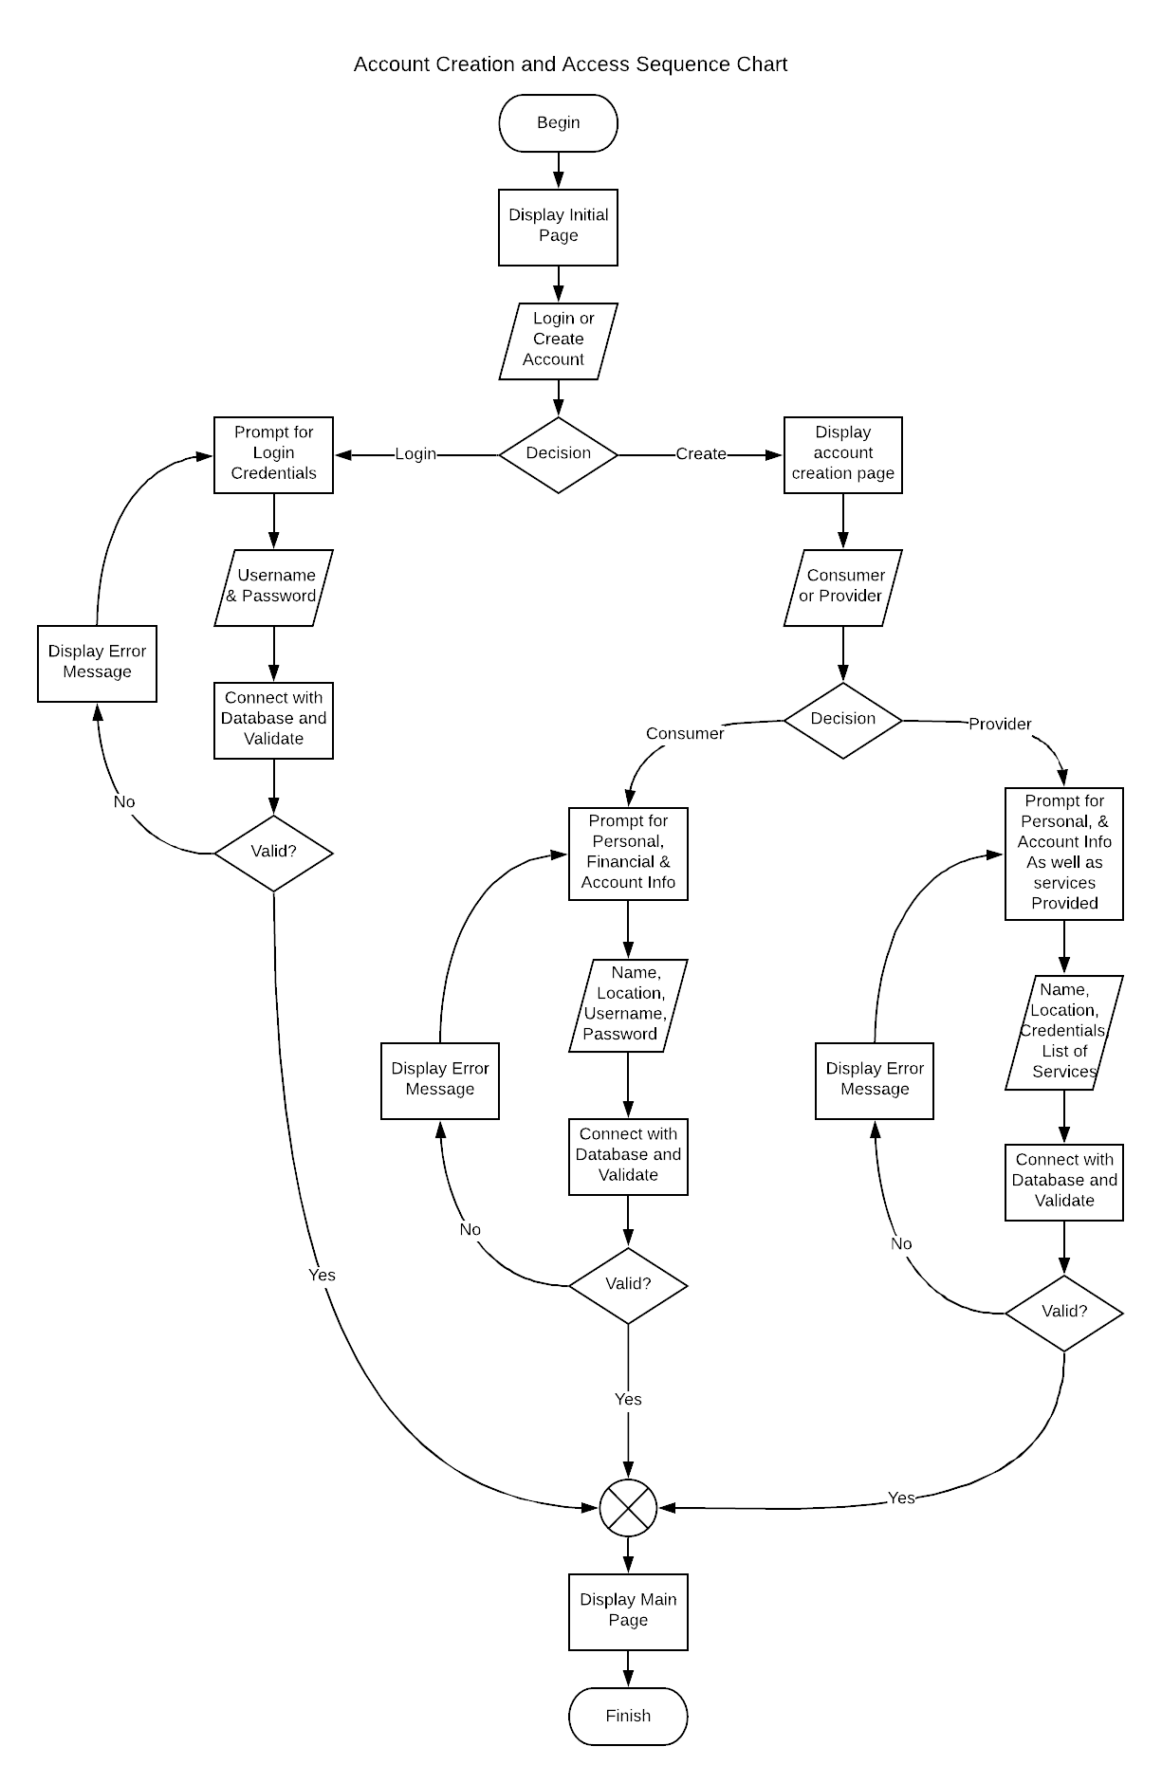

**Model Description:** This model covers the interaction the user will have with the system to either log into their accounts or create one. The system begins by displaying the initial page where the user will be asked if they wish to create an account or login. If the user wishes to log in, they will be prompted for their credentials, which will then be validated with the system’s database. If they prove to be valid, the user is taken to the main page; otherwise an error message will be displayed, and they will be taken to the login screen. If the user wishes to create an account, the system will ask if the account will be for a provider or a consumer. If it’s for a consumer, the system will prompt the user for their personal, financial, and account information; otherwise, they will be prompted for their personal information, as well as their credentials, and list of services they wish to provide. After the creation of the account, regardless if consumer or provider, the system will connect with the database and validate this information. If the data is valid, the user will be taken to the main page or, if it’s not valid, an error message will be displayed, and they will be taken to the account creation screen.

**Project Timeline**

Phase I: (March 6, 2020)

In this phase we will start implementing the base model of our project and setting up the user stories that will later turn into tasks/code.

Phase 2: (March 27, 2020)

In this phase we will start by completing the tasks in the product backlog while also reviewing which new tasks can be added as we progress or find any relevant ones. Testing will be done iteratively to ensure that the tasks are being validated and verified.

Phase 3: (April 17, 2020)

In this phase we will complete the implementation of the main application